**Lec04:**

Step 1

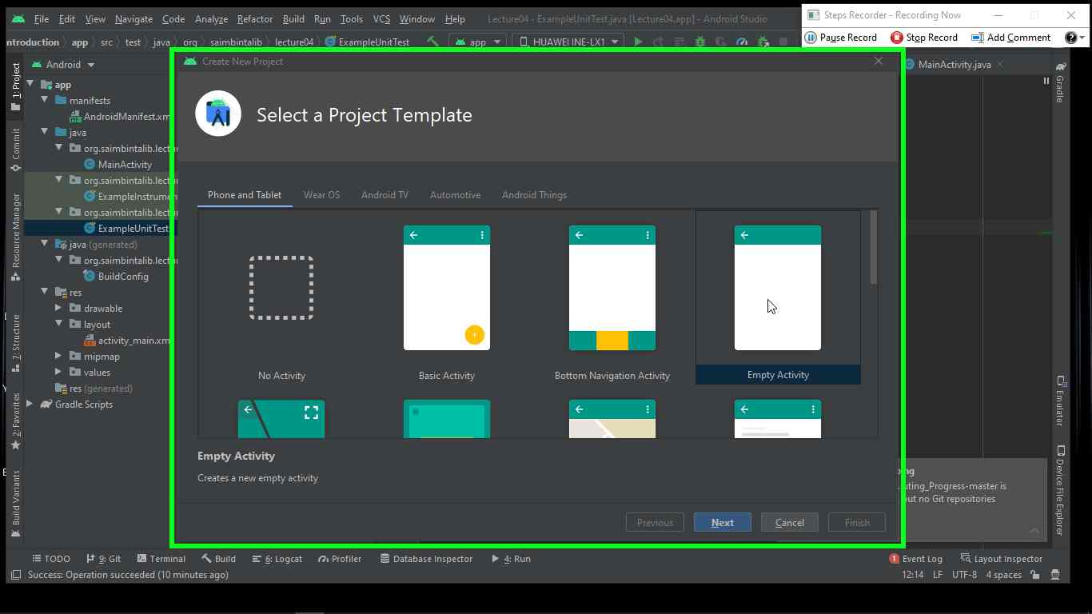

Previous Next

**Step 2:** User left cli ck on "Create New Project (window)" in "Create New Project"

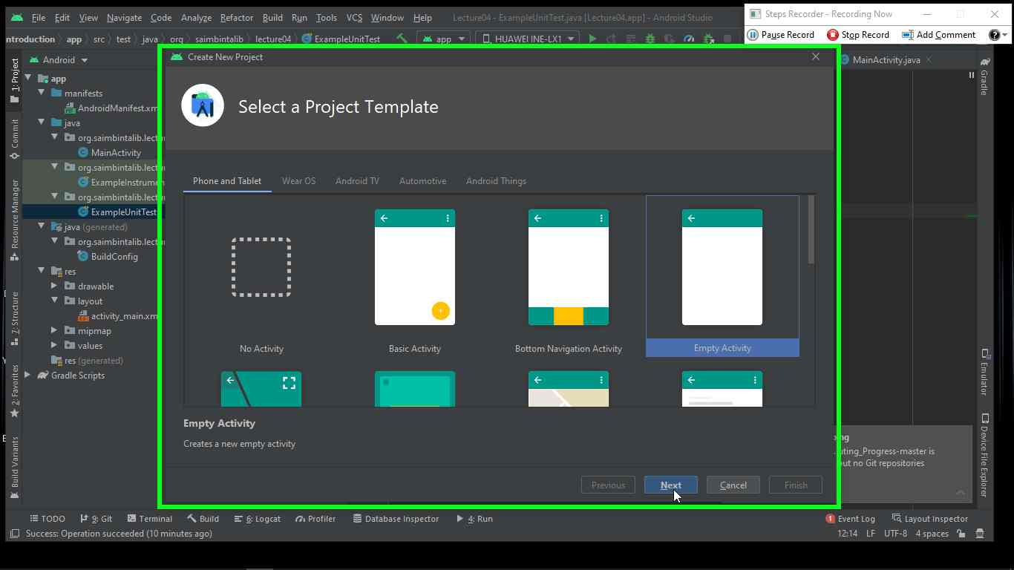

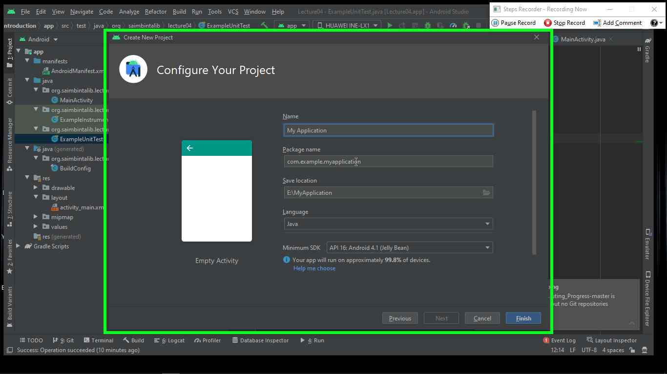Previous Next

**Step 3:**  User keyboard input on "Create New Project (window)" in "Create New Project “

Previous Next

**Step 4:** User left click on "Cre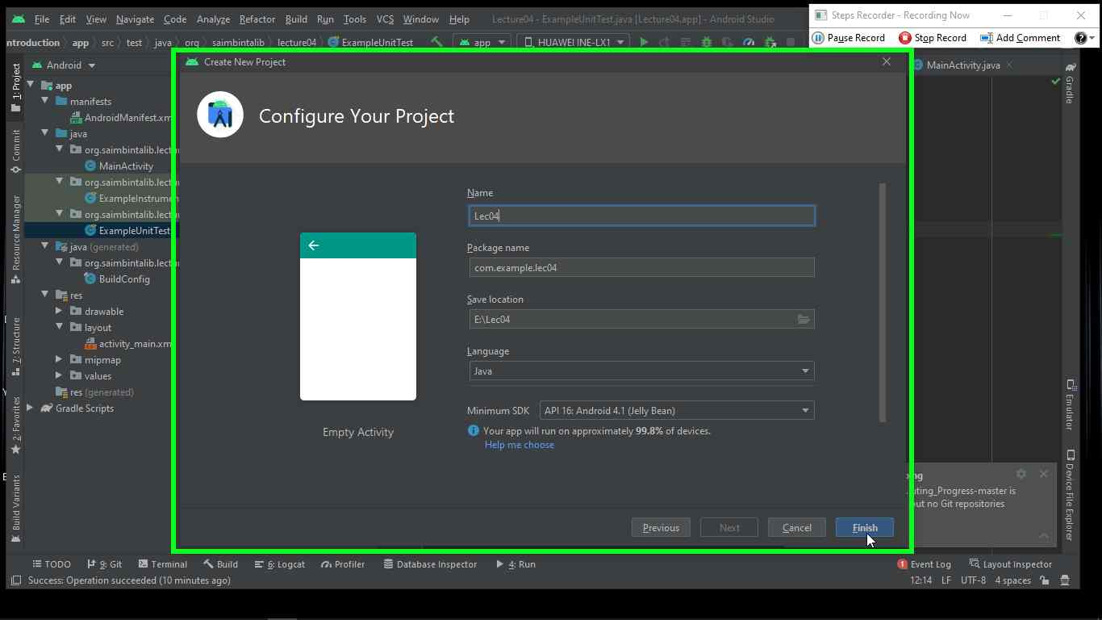ate New Project (window)" in "Create New Project"

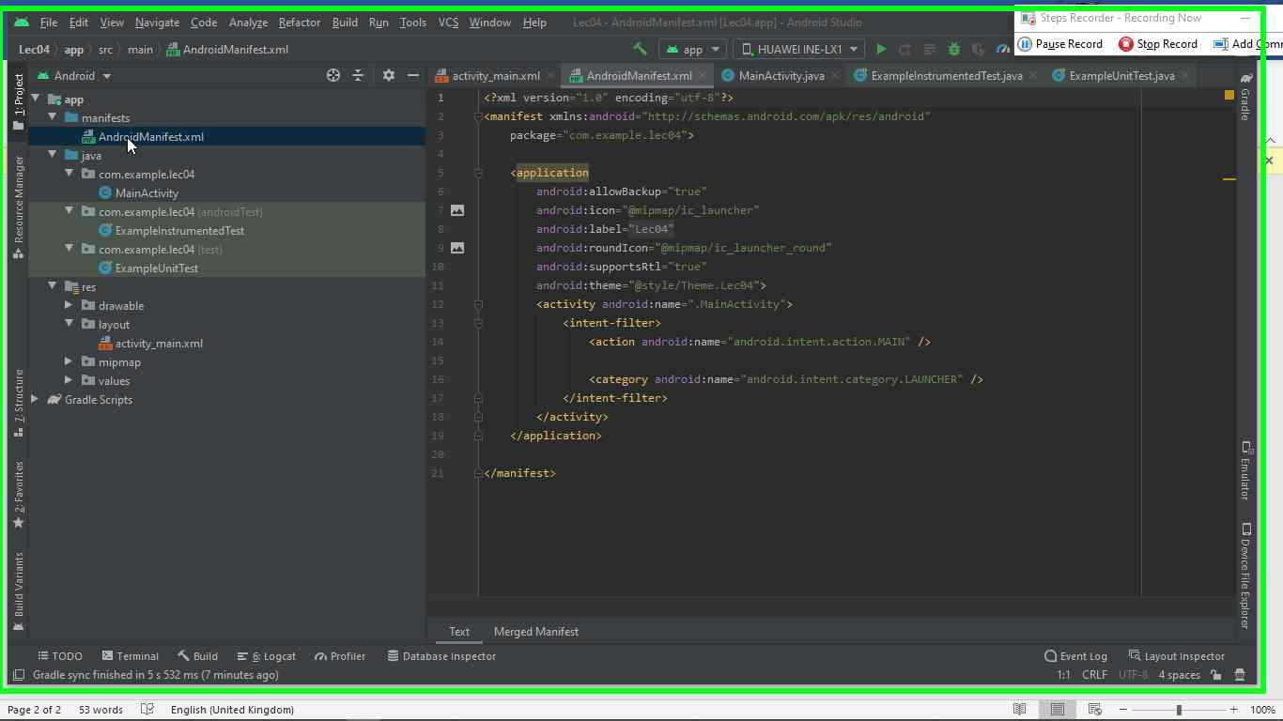

Step 5 screenshot.

Previous Next

**Step 6** "Lec04 – AndroidManifest.xml [Lec04.app] Android Studio (window)" 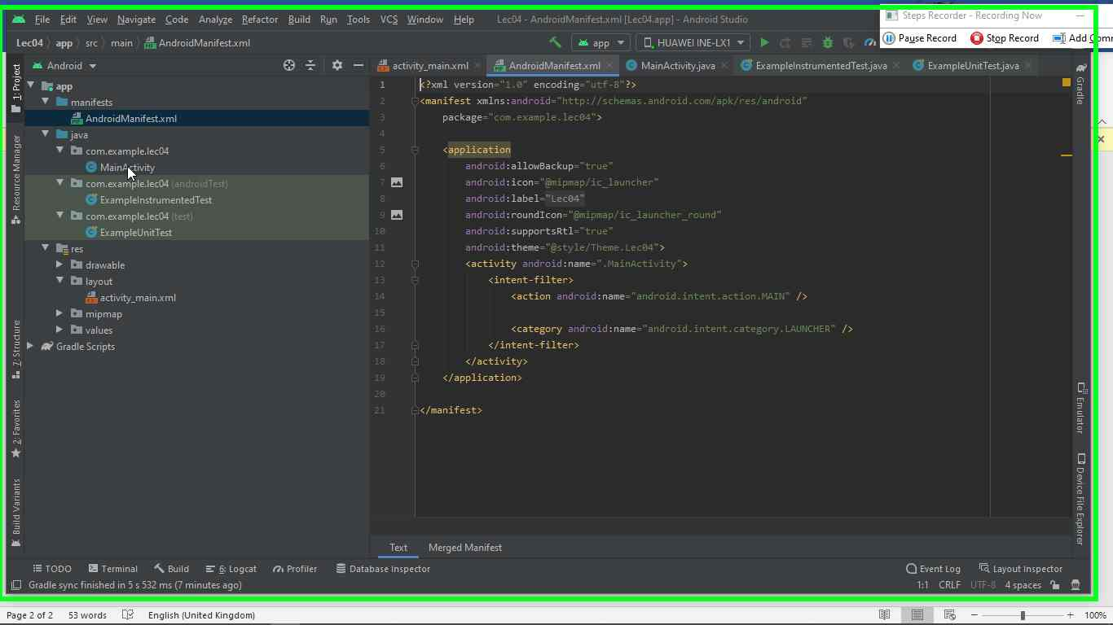4 – AndroidManifest.xml [Lec04.app] Android Studio"

Step 2 screenshot.

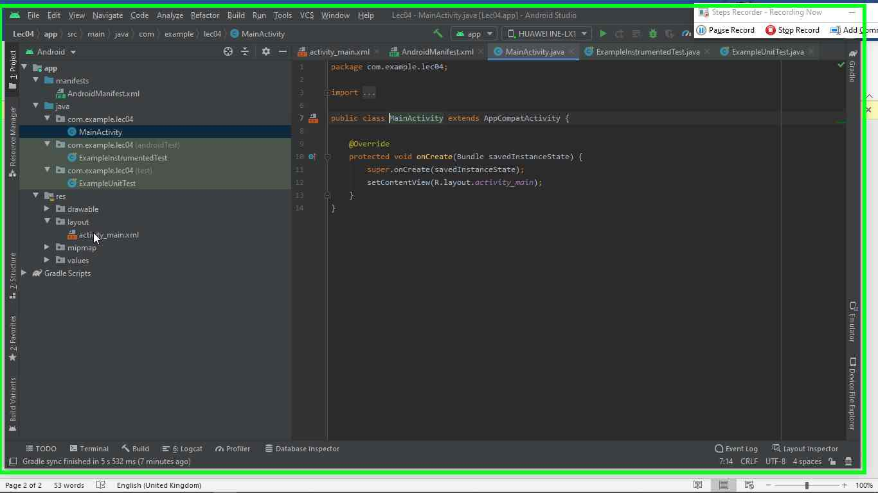Previous Next

**Step 7:** "Lec04 – MainActivity.java [Lec04.app] Android Studio (window)" in "Lec04 – MainActivity.java [Lec04.app] Android Studio"

Step 3 screenshot.

Previous Next

**Step 8:** "Lec04 – activity_main.xml [Lec04.app] Android Studio (window)" in "Lec04 – activity_main.xml 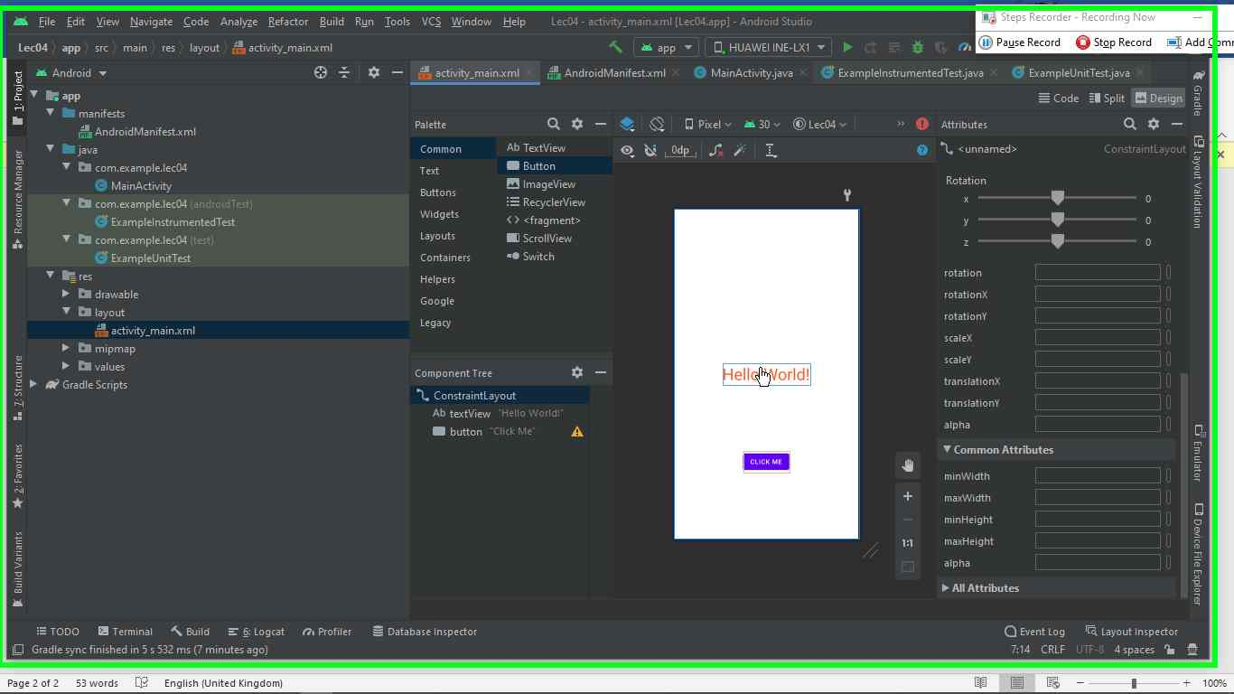

**Lec 05**

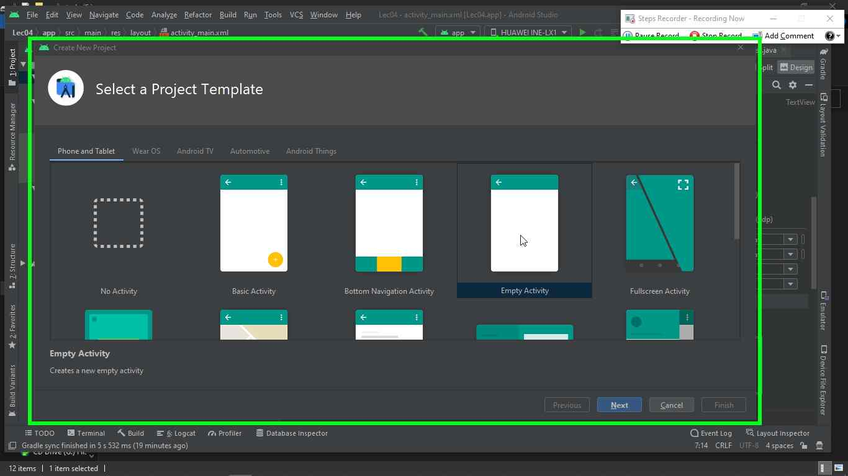

Previous Next

**Step 1:** User left click on "Create New Project (window)" in "Create New Project"

Step 1 screenshot.

Previous Next

**Step 2:** User left click on "Create New Project (window)" in "Create New Project"

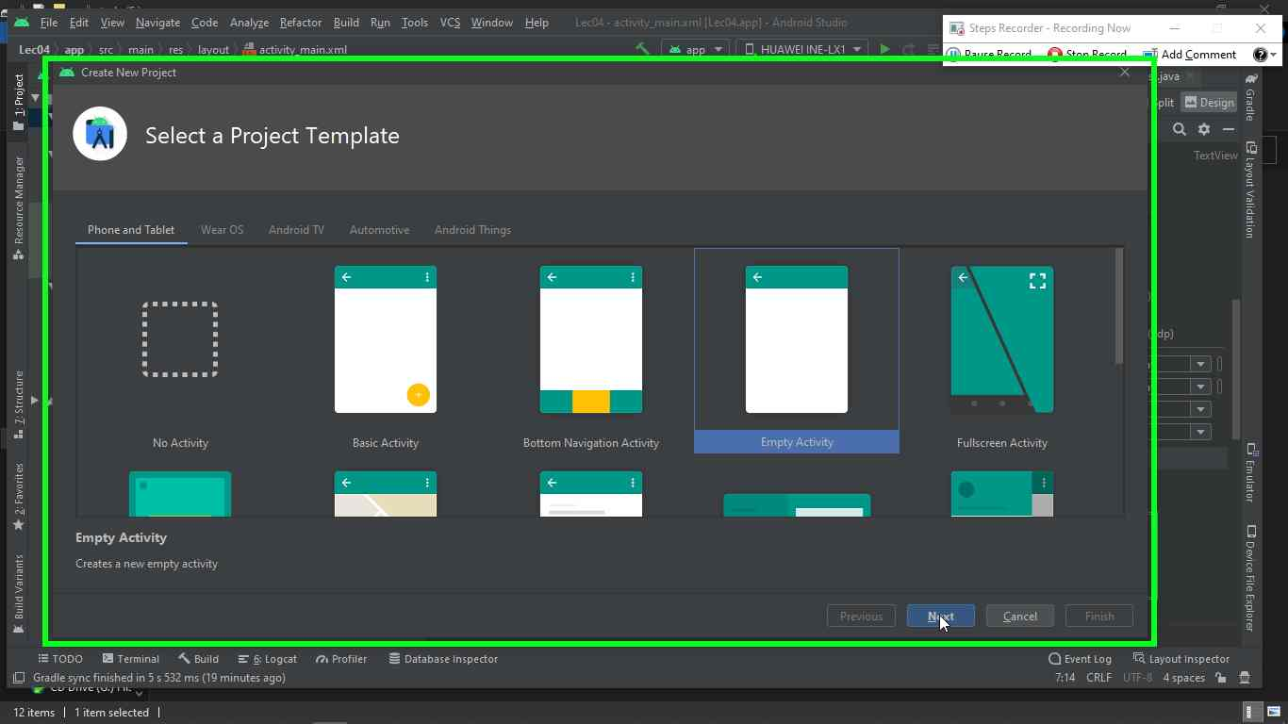

.

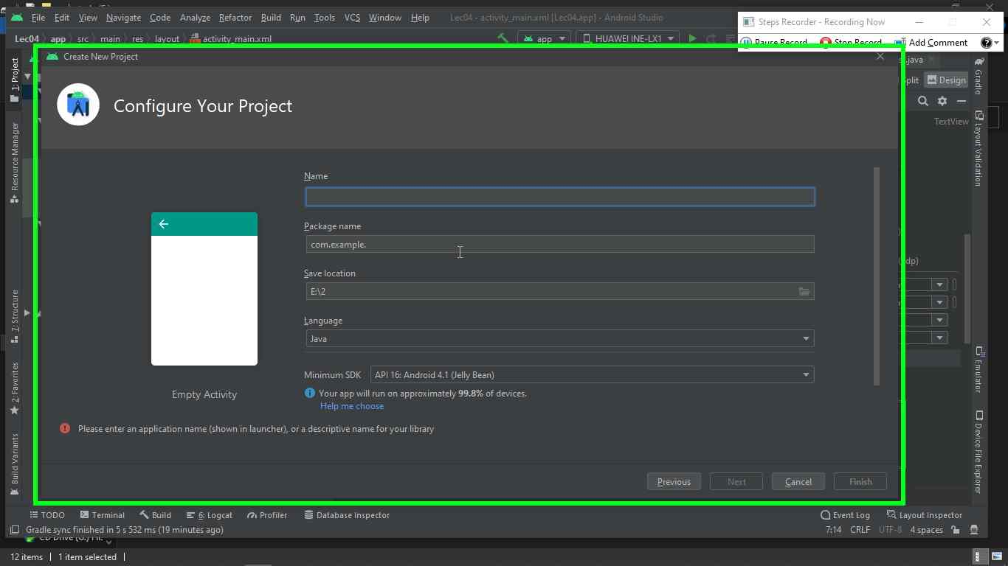

Previous Next

**Step 3:** User keyboard input on "Create New Project (window)" in "Create New Project"

Previous Next

**Step 4** User left click on "Create New Project (window)" in "Create New Project"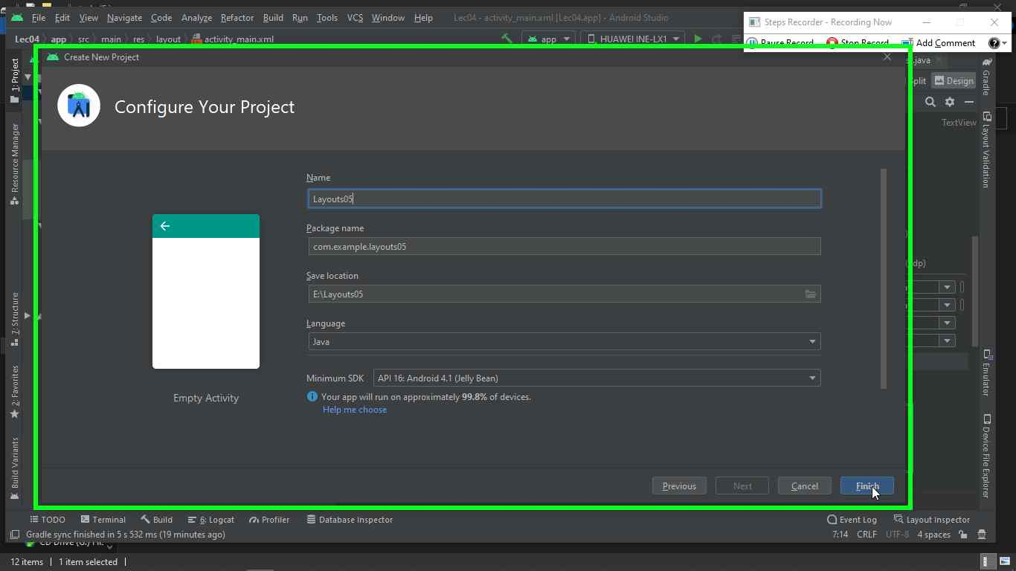

Step 4 screenshot.

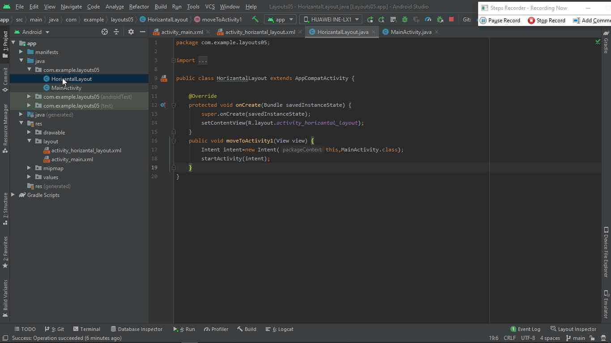

**Step 5:** "Layouts05 – HorizantalLayout.java [Layouts05.app] Android Studio (window)"

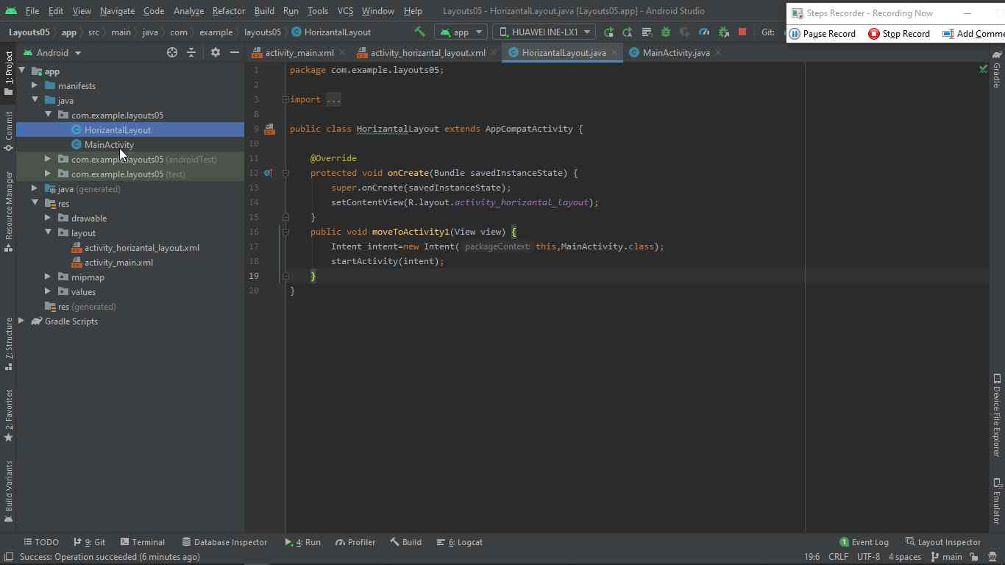

**Step 6:** Layouts05 – HorizantalLayout.java [Layouts05.app] Android Studio (window)"

**Step 7:** "Layouts05 – MainActivity.java [Layouts05.app] Android Studio (window)” 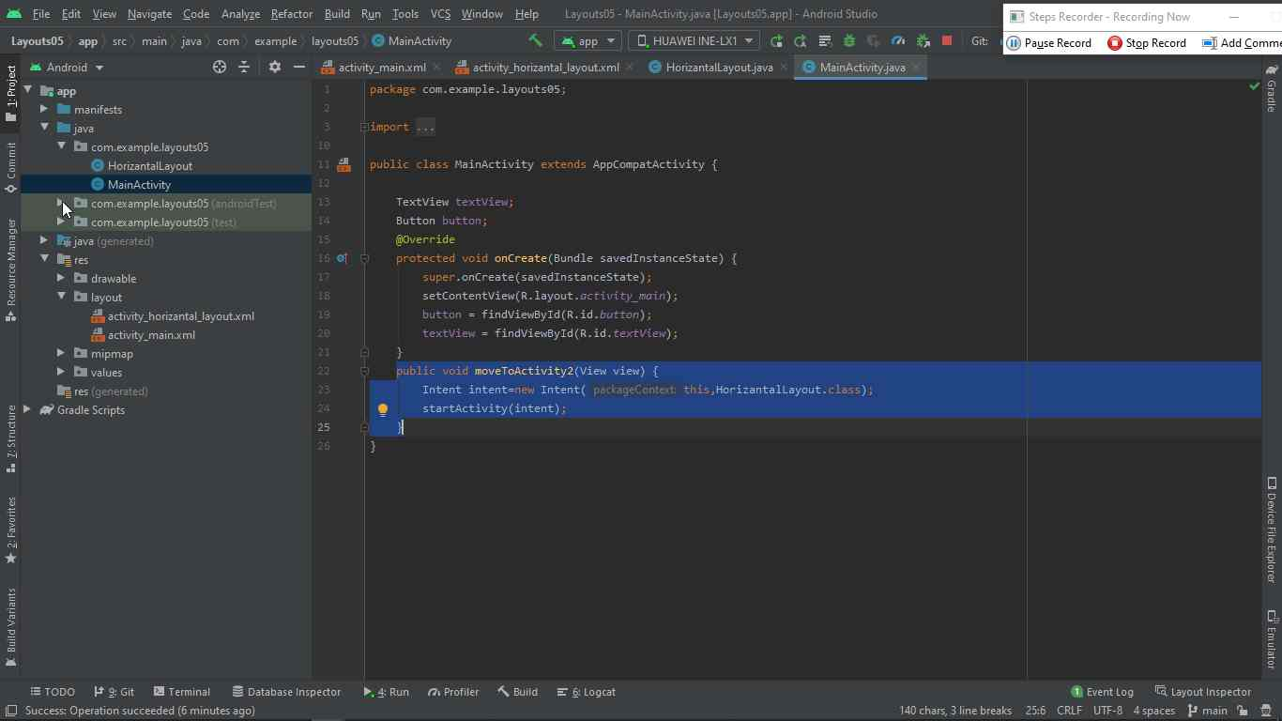

**Step 8:** "Layouts05 – MainActivity.java [Layouts05.app] Android Studio (window)" 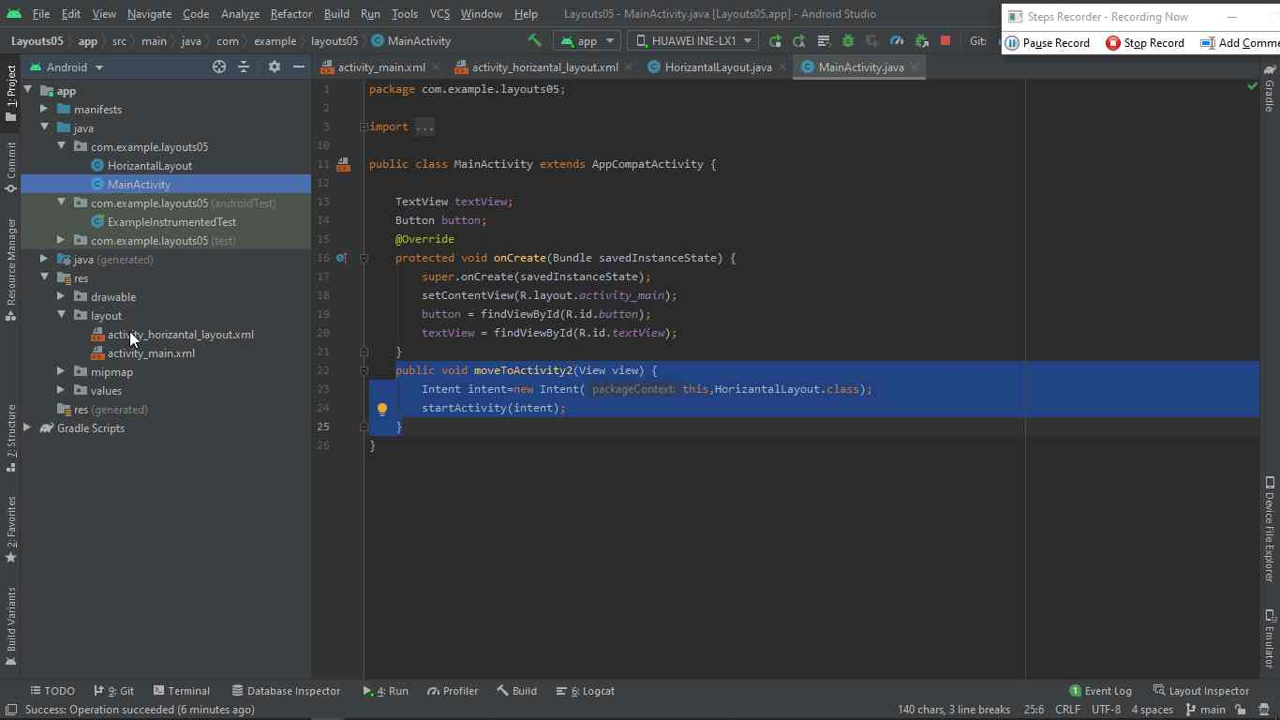

**Step 9:** "Layouts05 – activity_horizantal_layout.xml [Layouts05.app] Android Studio (window)" 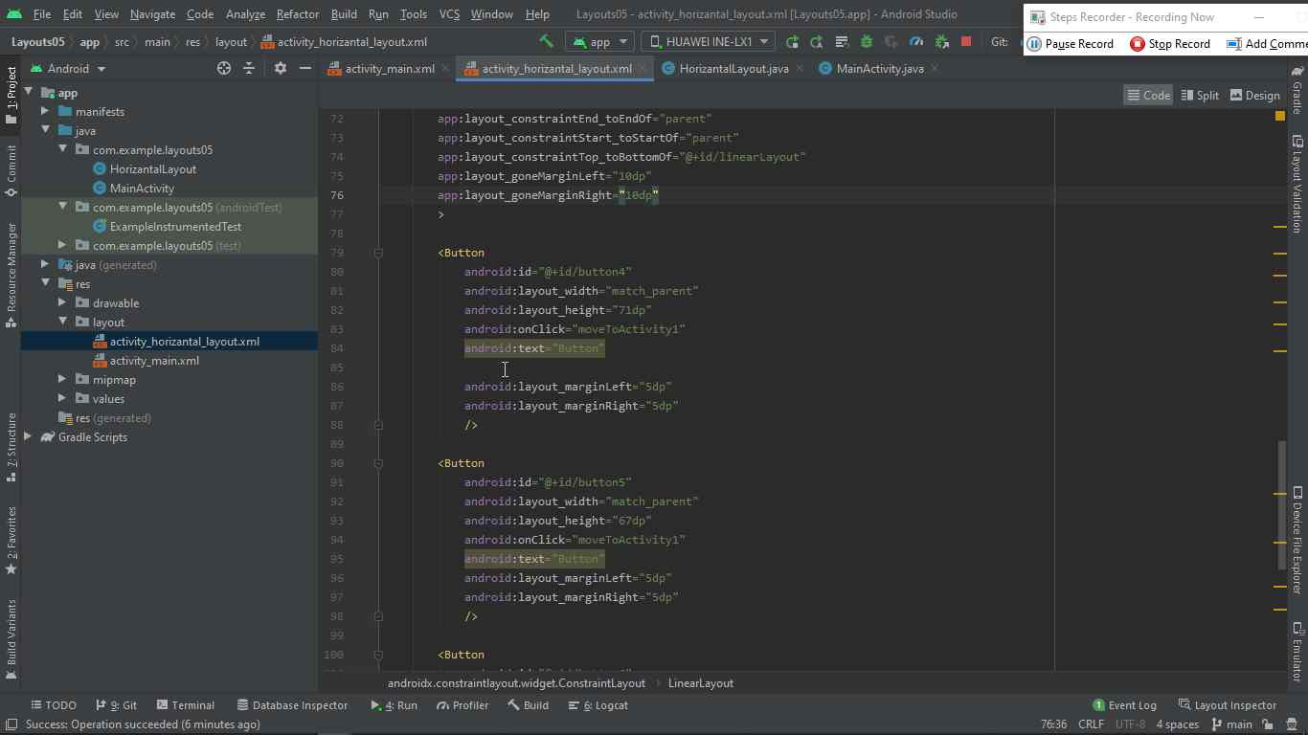

**Step 10:** "Layouts05 – activity_horizantal_layout.xml [Layouts05.app] Android Studio (window)" 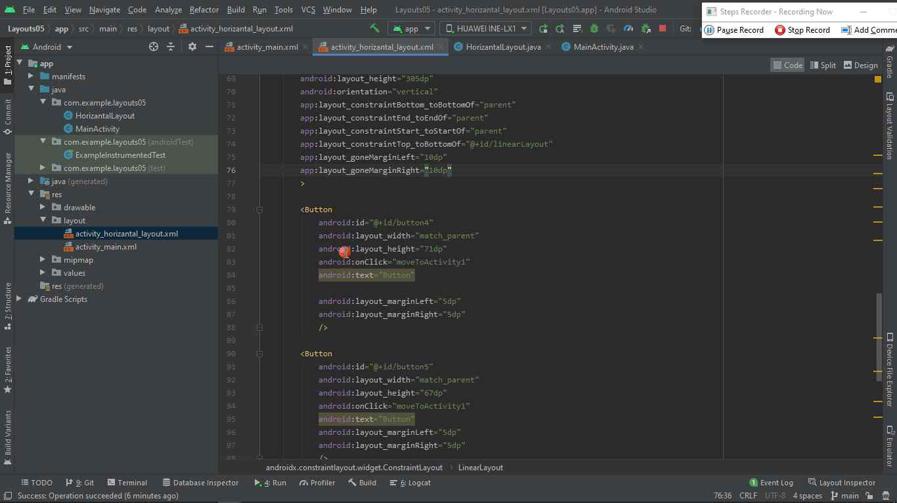

**Step 11:** "Layouts05 – activity_horizantal_layout.xml [Layouts05.app] Android Studio (window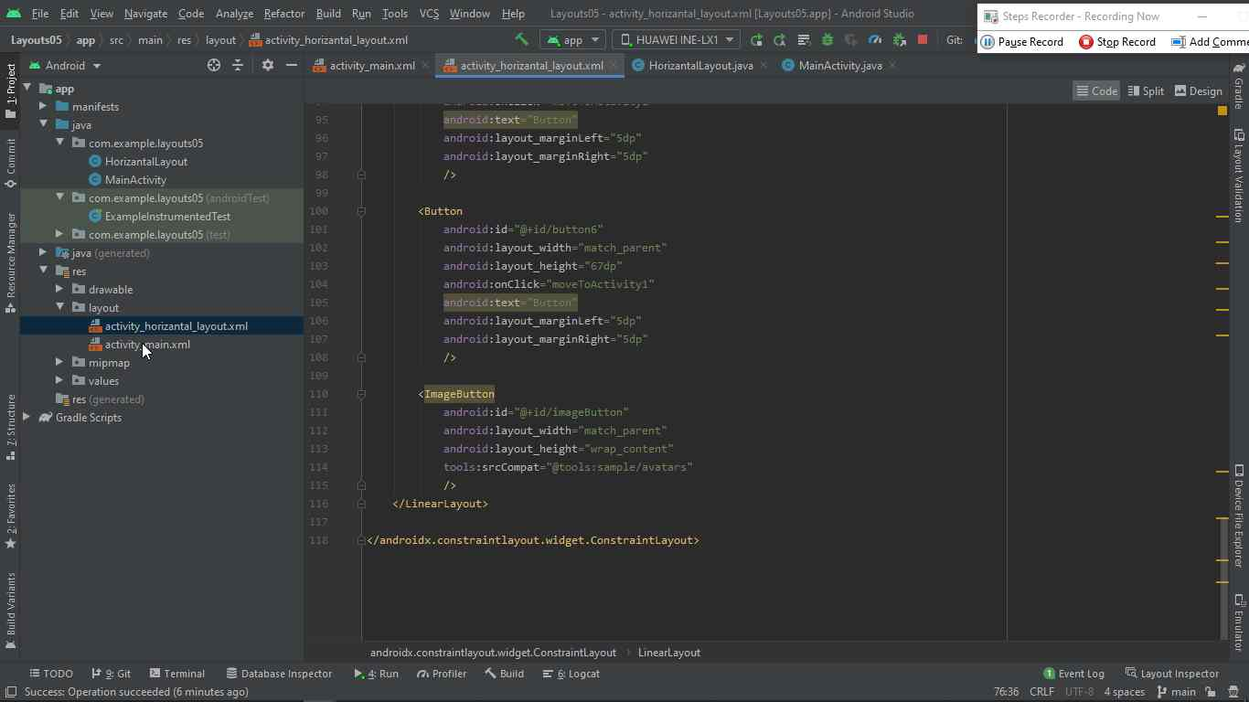

**Step 12:** "Layouts05 – activity_main.xml [Layouts05.app] Android Studio (window)" 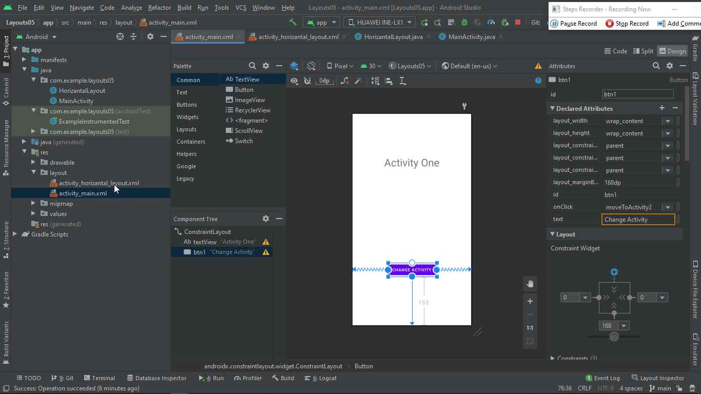

**Lec 06**

**Step 1:** User left click on "Create New Project (window)" in "Create New Project"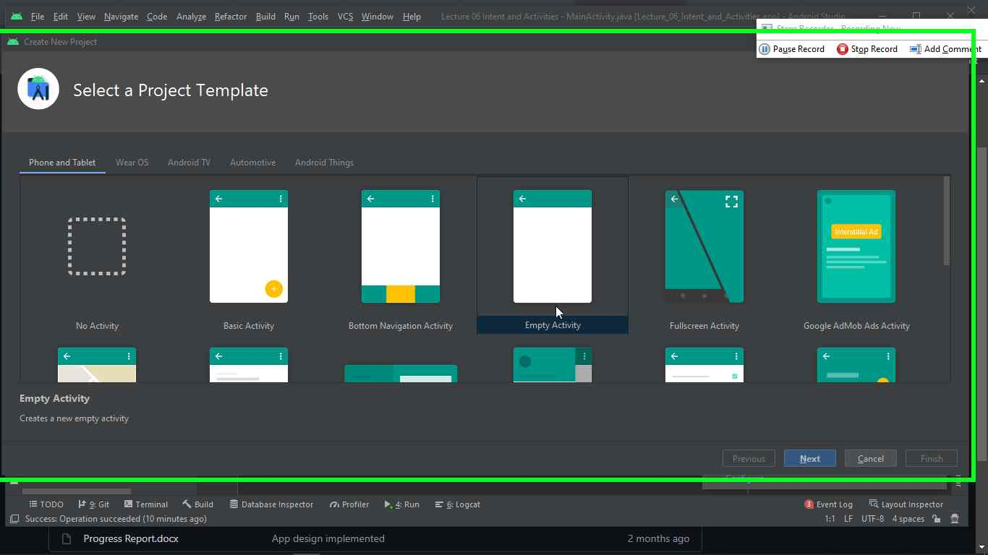

**Step 2:** "Create New Project (window)" in "Create New Project"

**Step 3:** "Create New Project (window)" in "Create New Project"

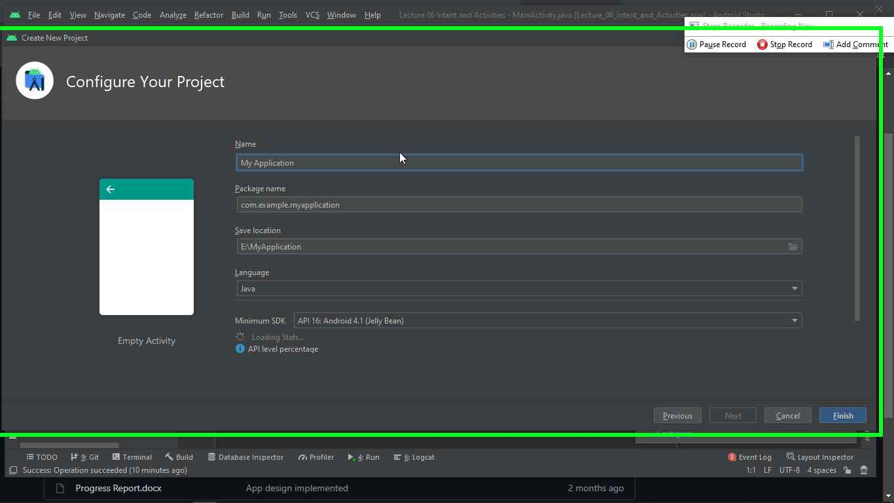

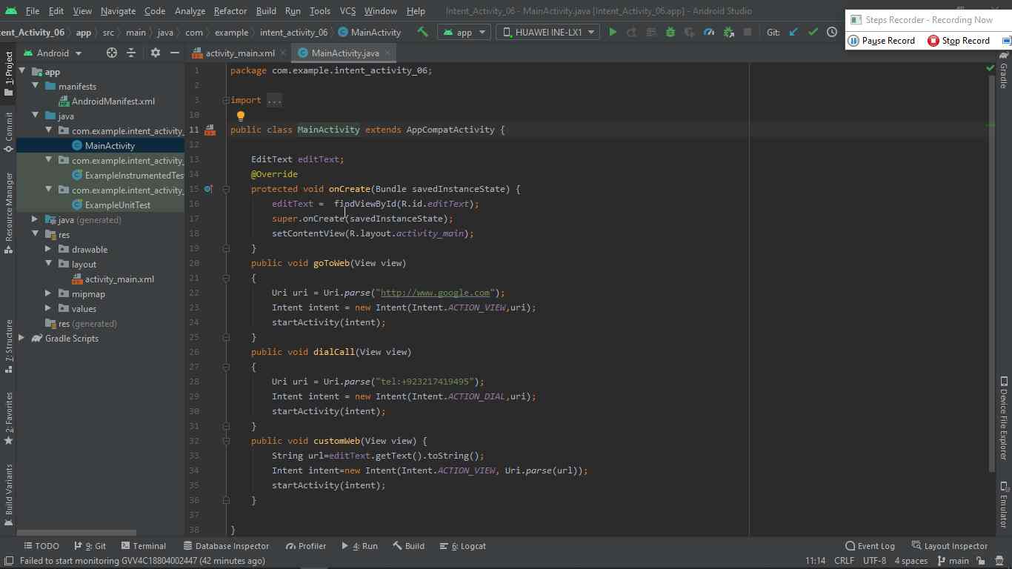

**Step 3:** "Intent_Activity_06 – MainActivity.java [Intent_Activity_06.app] Android Studio (window)"

**Step 4:** "Intent_Activity_06 – MainAc tivity.java [Intent_Activity_06.app]

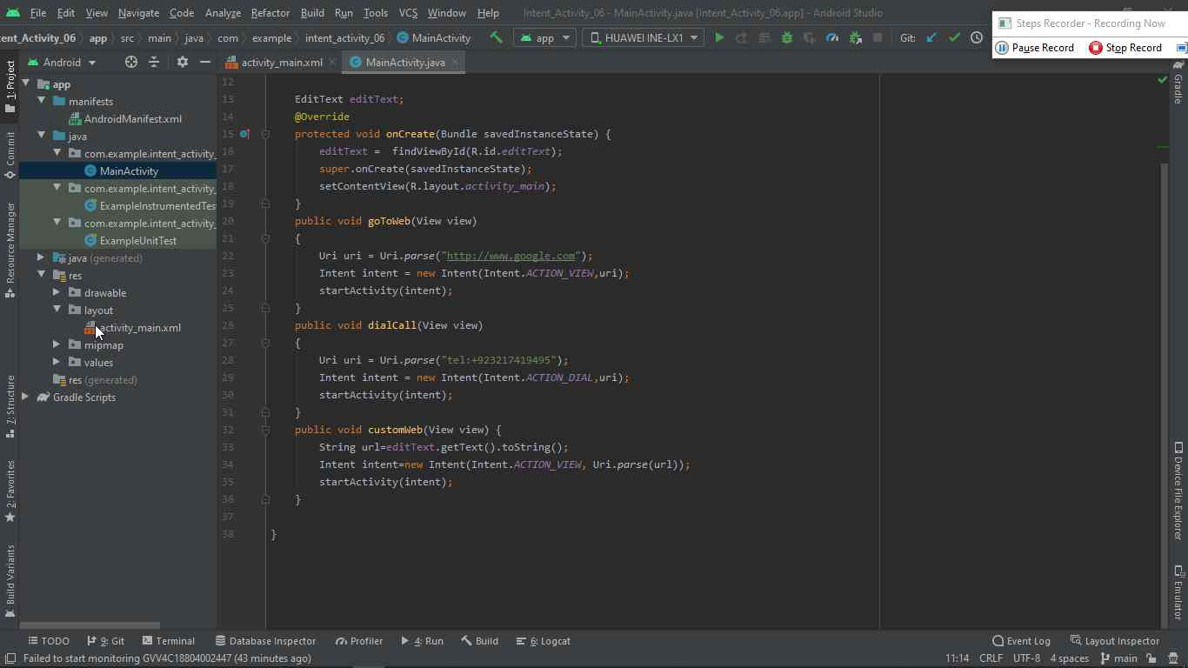

**Step 5:** "Intent_Activity_06 – activity_main.xml [Intent_Activity_06.app] Android Studio (window)" 